Step 1
Combined all the images that you shared and found a total of 8008 images.

Challenges
One of the core challenges was applying deep learning to hyperspectral data was the dimensionality mismatch sensor captures 944 spectral bands but ResNet accepts only 3 channels (RGB).

Encountered an error below:
TypeError: Cannot handle this data type: (1, 1, 944), |u1
Band strategy is the method I used to bridge this gap. Tested four approaches ranging from arbitrary selection to mathematically optimal PCA decomposition.

Experiment Baseline
it was a BYOL , backbone = ResNet18, band strategy = First, Mid, Last, epochs = 50, final loss = -0.9994 , standard deviation = 36.2562.
band strategy, picked the first band, middle band and last band — meaning we took three complete views of the same road scene, each captured at a different wavelength and combined them into a single 3-channel image for the model to learn from.

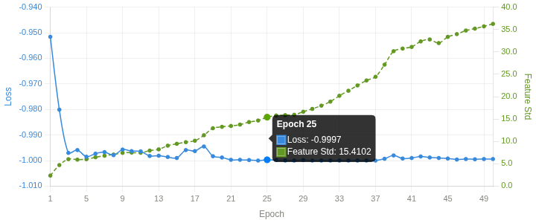

Results : no collapse or trivial solutions

Experiment 3A Maximum variance bands.
The idea is that bands with high variance across images contain the most information, they are the ones where pixel values differ a lot between images. Low variance bands look nearly the same in every image and teach the model nothing. Compute the standard deviation of each band across a sample of images and pick the top 3.
Backbone = ResNet18, band strategy = maximum variance , epochs = 50, final loss = -0.9997, standard deviation = 37.84.

band selection max. variance: takes a data-driven approach to band selection. Rather than picking fixed spectral positions, it analyses all 944 bands of each individual image, measures how much pixel variation each band contains, and selects the 3 bands with the highest variance. The idea is bands where pixels vary greatly contain more information about road surface structure than bands where all pixels look identical.

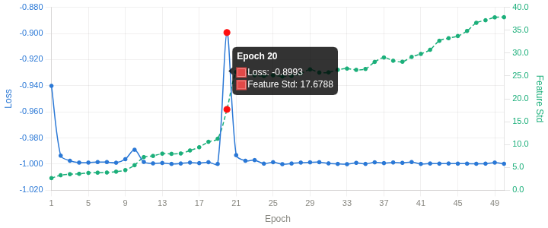
Results: no collapse. The model reorganized itself at epoch 20 and the following happened Loss jumped from -0.9998 back to -0.8993, Feature Std leapt from 11.28 to 17.68 (almost 57% in one epoch) and Feature spread exploded to ±5.78.

Experiment 3B

backbone = ResNet18, band strategy = evenly spaced, epochs = 50, final loss = -0.9996, final standard deviation = 40.00.
band selection evenly spaced divide into equal parts and pic bands at the boundaries.

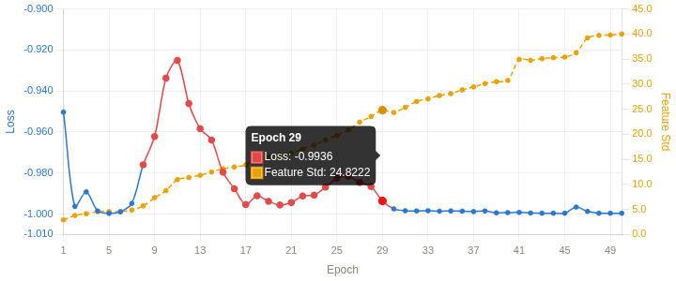
Results : no collapse or trivial solutions
Experiment 3C

backbone = ResNet18, epochs = 50, band strategy = PCA, final loss = -0.9981, standard deviation = 36.
band strategy PCA rather than selecting existing spectral bands, PCA analyses all 944 bands simultaneously and synthesises 3 new channels that mathematically capture the maximum possible variance from the entire spectrum.

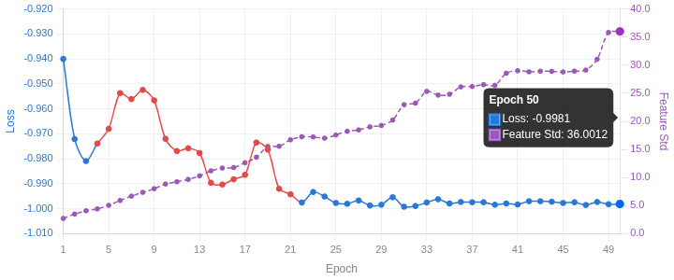
Results no collapse or trivial solutions.

Experiment 1

backbone = ResNet50, epochs = 50, brand strategy = evenly spaced, final loss = -0.9954, standard deviation = 43.82.
band strategy evenly spaced, divide into equal parts and pic bands at the boundaries.

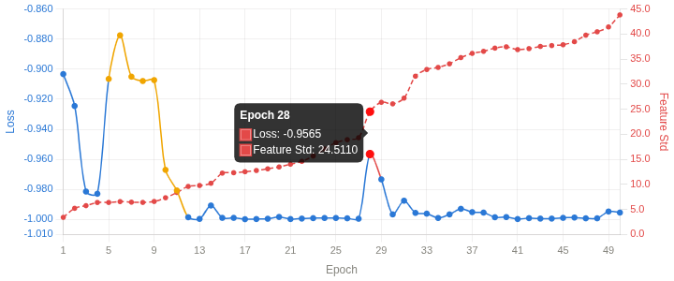
Results no collapse.
Experiment 5

backbone = ResNet50, epochs = 100, band strategy = evenly spaced, final loss = -0.9998, standard deviation = 62.63

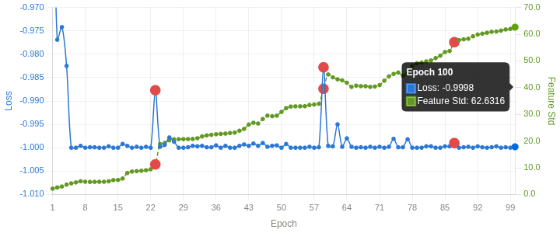

Results no collapse. Three reorganizations at epoch 23, 59 and 87. Loss temporarily rises, Feature Std jumps in 1–2 epochs and the model settles at a completely new higher level and never drops back.

Experiment 6 Evaluation Phase

It was about one thing only did the representations BYOL learned during those 100 epochs actually capture something real and useful about road surfaces? Tested whether those descriptions were useful Froze the model (no more learning ). Added one linear layer on top Achieved 100% accuracy Silhouette Score 0.9998.

Conclusion: BYOL learned genuinely meaningful road surface representations without any labels.
Currently ResNet50 100 epochs is the best overall model. Yet to run ResNet18 PCA(band strategy) on 100 Epochs.

